

**SUITABILITY STUDY FOR URBANIZATION USING AHP MODEL FOR CHENNAI AND CHENGALPATTU DISTRICTS, TAMIL NADU**

**Mini Project work submitted for the partial fulfillment of the degree Bachelor of Technology in**

**GEOLOGICAL TECHNOLOGY AND GEOINFORMATICS**

*Submitted By*

*R. PRIYADHARSHAN (18MTGT23)*

Under the guidance of

DR.K.PALANIVEL

PROFESSOR AND HEAD

DEPARTMENT OF REMOTE SENSING

BHARATHIDASAN UNIVERSITY

TIRUCHIRAPPALLI-23

**DEPAR**

**Nov - 2021**



**DEPARTMENT OF REMOTE SENSING**

BHARATHIDASAN UNIVERSITY

TRICHIRAPALLI

**BONAFIDE CERTIFICATE**

Certified that this project“**SUITABILITY STUDY FOR URBANIZATION USING AHP MODEL FOR CHENNAI AND CHENGALPATTU DISTRICTS, TAMIL NADU”.** is a Bonafide work of **R. Priyadharshan** (18MTGT23)who all carried out the project work under our supervision for the partial fulfillments of the 6Year Intergrated M.Tech Geological Tech nology and Geoinformatics programme. This is to further state that the work was not submitted earlier to any other institution for other degree or diploma.

**SIGNATURES:**

**Supervisor**

**External Examiner:**

**DR. K. Palanivel**

**PROFESSOR AND HEAD Department of Remote Sensing**

**Bharathidasan University**

**Trichy - 23**

**DEPARTMENT OF REMOTE SENSING**

BHARATHIDASAN UNIVERSITY

** TIRUCHIRAPPALLI-23**

**DECLARATION**

We hereby declare that the dissertation entitled **“SUITABILITY STUDY FOR URBANIZATION USING AHP MODEL FOR CHENNAI AND CHENGALPATTU DISTRICTS, TAMIL NADU”** has been carried out entirely by us under the guidance of **Dr.K.Palanivel** as our Mini project of 6 years Intergrated M.Tech program in **GEOLOGICAL TECHNOLOGY AND GEOINFORMATICS** 4th Year 8th semester of Department of Remote Sensing, Bharathidasan University, Tiruchirappalli-23.

Place: **Tiruchirappalli**

Date**: 24/06/2021**

**M. Manoj Bharathi - 18MTGT14**

**B.N. Nithiya Prasinna - 18MTGT20**

**R. Priyadharshan - 18MTGT23**

**ACKNOWLEDGEMENT:**

It is our great privilege to express our heartfelt gratitude and respect to

all those who guided and inspired us to complete our project.

We wish to express our deep sense of gratitude to our guide

Dr.K.Palanivel, Professor and Head, Department of Remote Sensing, Bharathidasan University for his guidance and also for thoughtful suggestions, which helped us in completing the project on time. We also learnt a handful of knowledge through him.

We also thank Dr.A.Balukkarasu (Professor), Dr.C.LAKSHUMANAN (Professor), Dr.D.Ramesh (Associate Professor), Dr.J.Saravanavel (Assistant Professor), and Dr.A.Muthamilselvan, Assistant Professor for helping us to carry out this project work.

We are very thankful to our scholars and our seniors for their timely

help and patience in supporting us to complete this project.

Above all we thank God and our parents for making this project successful with their support and encouragement. We thank them for giving us strength and moral support to pursue this training without any hindrance. We hereby record our sincere thanks to each and everyone who helped in making out this project to submit on time without any delay.

This project cannot be completed without the effort and cooperation from our team members who was extremely helpful in each and every part of it.

Thanks to all.

Place: Tiruchirappalli

Date: 30.11.2021

# ABSTRACT:

Urbanization is a continuously progressing event, now-a-days rapidly expanding due to fast increasing population in our country. It is important to identify Suitable housing areas for future development in a sustainable manner with proper geological considerations. The GIS-based spatial multi-criteria evaluation approach, in terms of the AHP model was used to assess the land suitability for sustainable urban development. Land suitability analysis carried out as a case study for Chennai and Chengalpattu districts which are among the urbanized areas and upcoming spread of urbanization.  Land suitability analysis has become inevitable for delineating appropriate site for various developmental initiatives. The land suitability analysis adds importance to study by helping to identify suitable sites that meet specific criteria. Proper urban development occurs when it is done based on the correct planning and suitable utilization of the land. Data used in this case study are: LANDSAT-8 raw and FCC and CARTOSAT DEM data sets. The goal of this study is to define the areas that are appropriate for building constructions by using AHP model which is expected to give proper decision to locate and rank suitable sites for urbanization. The evaluating process for site suitability conducted is based on seven criteria including Land use and Landcover, Ground water potential, Soil, Geomorphology, Slope, Distance from roads and water bodies. A weight scheme for each criterion and its content was generated by comparing them with each other according to their importance. With the help of these weights, final site suitability map was prepared. The results of the site suitability analysis produce a detailed display of the most-suitable areas for consideration of placement of urbanization facility, while filtering out sensitive / unusable or less desirable sites. The final resulted output is classified into five prioritized categories for urbanization in the study area viz.: Very High, High, Medium, Low, Very Low. It provides comprehensive and satisfactory database for the availability of suitable land for urban development. This model also encourages public participation in the urban decision making process and suggest planners and authorities a suitable plan for sustained development of the region.

Contents

**ABSTRACT: 5**

**1. INTRODUCTION: 11**

**1.1. GENERAL: 11**

**1.1. AIM: 14**

**1.2. OBJECTIVES: 15**

**1.3. NEED FOR LAND SUITABILITY: 15**

**1.4. STUDY AREA: 17**

**1.5. DATA SETS AND METHODOLOGY: 20**

**2. AHP MODELLING: 23**

**3. INTEGRATION OF GIS DATA AND AHP MODELLING: 24**

**4. DATA BASE GENERATION: 25**

**4.1. THEMATIC MAPS: 25**

**4.1.1. LITHOLOGY MAP: 25**

**4.1.2. SHADED RELIEF MAP: 26**

**4.1.3. LINEAMENT AND LINEAMENT DENSITY: 28**

**4.1.4. GEOMORPHOLOGY: 30**

**1.1.1. SLOPE MAP: 32**

**1.1.2. ASPECT MAP: 34**

**1.1.3. DRAINAGE AND DRAINAGE DENSITY MAP: 37**

**1.1.4. LANDUSE AND LAND COVER MAP: 38**

**1.1.5. SOIL MAP 40**

**4.2. ADDITIONAL CRITERIA MAPS: 42**

**4.2.1. NDBI: 42**

**4.2.2. NDWI: 44**

**4.2.3. SMI: 45**

**4.2.4. GROUND WATER QUALITY: 47**

**4.2.5. GROUND WATER POTENTIAL: 49**

**4.2.6. DISTANCE FROM WATER BODIES: 55**

**4.2.7. DISTANCE FROM ROADS: 57**

**5. RESULTS AND DISCUSSIONS: 59**

**5.1. INTERGRATION OF MAPS AND PREPARATION OF FINAL SUITABILITY MAP: 59**

**5.1.1. GEOMORPHOLOGY: 60**

**5.1.2. SOIL: 61**

**5.1.3. GROUND WATER POTENTIAL ZONE: 63**

**5.1.4. DISTANCE FROM ROAD: 64**

**5.1.5. DISTANCE FROM WATER BODIES: 64**

**5.1.6. LANDUSE AND LAND COVER: 65**

**5.1.7. SLOPE MAP: 66**

**5.1.8. AHP – LAND SUITABILITY: 67**

**6. CONCLUSIONS: 69**

**7. REFERENCES: 70**

**LISTS OF FIGURES**

Figure 1 - Satellite image of the Study area 18

Figure 2 - Base map of the Study area 19

Figure 3 - Lithology map 26

Figure 4 - Shaded Relief Maps 27

Figure 5 - Lineament map 28

Figure 6 - Lineament Density 29

Figure 7 - Geomorphology map 31

Figure 8 - Slope map 33

Figure 9 - Aspect map 36

Figure 10 - Drainage and Drainage Density 38

Figure 11 - LULC map 40

Figure 12 - Soil map 41

Figure 13 - NDBI map 43

Figure 14 - NDWI map 45

Figure 15 - Soil Mositure Index 46

Figure 16 - Ground Water Quality 48

Figure 17 - Ground Water Potential zone 54

Figure 18 - Distance from Water Bodies 56

Figure 19 - Distance from Road 58

Figure 20 - AHP - Land suitability map 68

**LISTS OF FLOWCHARTS**

**Methodology 1 19**

**Methodology 2 20**

# INTRODUCTION:

## GENERAL:

Current decades, urbanization has become a eminent and developing trend that it has led to drastic change in the human interactions with the environment and other people all over the world (Aliani et al. 2021). A lot of efforts have been made by the Centre and the State Governments in the urban sector. However, urban planning, which is the foundation for the integrated development of cities, citizens, and the environment, has not received adequate attention. The development of the Urban Growth has increased tremendously and the major cities in India like Chennai and the upcoming urbanized cities like Chengalpattu has widely developed. Urbanization is the at most development of urban areas or the territorial progress of a neighborhood as a result of rise in population due to resettling or concentration into cities (Aithal and Ramachandra 2016). Urbanization and the diffusion of haphazard settlements belong to the most important features of the spatial development in many industrialized countries (Murgante and Casas 2004). Only 14 % of the world’s population lived in urban areas in 1900, which increased to 47 % by 2000 Specifically if looked at Indian case in 2011, 31.16 % of India’s 1.2 billion people lived in urban areas (<https://censusindia.gov.in/>) and this is projected to reach 60 % by 2030 (Aithal and Ramachandra 2016). However, the rapid growth of urban areas has led to complex problems, including traffic congestion, environmental pollution, reduced open space, the deterioration of old, downtown centers, and unplanned or poorly planned land development (Park et al. 2011). In order to prevent that we need to be finding a suitable area for further development or evaluation of land suitability for urban land use planning to overcome undesirable urban growth and protect environment around cities becomes all the more important (Parry, Ganaie, and Sultan Bhat 2018).`Sustainable development’ is also considered as **`a process of social and economic betterment that satisfies the needs and values and of all interest groups, while maintaining future options and conserving natural resources and diversity’**(Yeh and Li 1998). Land suitability analysis helps in identifying suitable sites that meet specific criteria or restrictions. This analysis greatly reduces the time as well as effort that have to be put in otherwise in manually searching the records, processing data and undertaking field surveys (Kumar and Shaikh 2013). It is the fundamental work and the essential content of overall land use planning, which requires a scientific approach, in addition to guide development, avoidance of errors in decision-making and over-investment, for sustainable utilization of land resources (Bagheri, Sulaiman, and Vaghefi 2013).The Urban Growth which is mention implies in all categories driven by population increase, urban growth alters the community’s social, political and economic institutions with changing land use and also affects the local ecology and environment (Aithal and Ramachandra 2016). A proper urban development occurs when it is done based on the correct planning and suitable utilization of the land, in accordance with its potential and production capabilities. Therefore, optimizing the ways of developing cities, controlling them to meet current needs, and predicting future urban needs are essential for planning and moving along the principles of sustainable development (Aliani et al. 2021).GIS is known as a powerful tool for handling spatial data in land-use analysis (Bagheri, Sulaiman, and Vaghefi 2013). The results of the site suitability analysis produce a de-tailed display of the most-suitable areas for consideration of placement of a certain facility, while filtering out unusable or less desirable sites (Kumar and Shaikh 2013). The objective of this study is to determine if there are suitable areas of certain criteria according to the choices needed.When performing land suitability and site selection analysis we must set various criteria from which using the GIS software we can rate the best or ideal sites mainly to determine the appropriateness of a given area for a particular use. The basic premise of GIS in land suitability analysis is that each aspect of the landscape has intrinsic characteristics that are to some degree either suitable or unsuitable for the activities being planned. Combining GIS and MCDA is also a powerful approach to land suitability assessments. GIS enables computation of the criteria while a MCDA can be used to group them into a suitability index (KUMAR and BISWAS 2013). Land Suitability Analysis is a GIS-based process applied to determine the suitability of a specific area for considered use (Jafari and Zaredar 2010). Suitability is determined through systematic, multi-factor analysis of the different aspects of the problem (Parry, Ganaie, and Sultan Bhat 2018). Land use planning and management can be effectively carried out by integrating Geographic Information System (GIS) and multi-criteria decision analysis (MCDA) technique has the ability to solve problems related to spatial decision involving conflicting criteria (Jamil, Ahmed, and Sajjad 2018). It is one of the successful and most widely used approaches which greatly reduces the time as well as effort is pair wise comparison method(KUMAR and BISWAS 2013). Analytic Hierarchy Process method is a vital tool for identification, comparison and multi-criterion decision making analysis of urban development site’s proper planning and management (Parry, Ganaie, and Sultan Bhat 2018). AHP is commonly applied to identify the weights of influencing factors on urban growth on the basis of the analysis functions of GIS. AHP is also a structured approach that can be used for complex cases of making decisions that include competing criteria (Aburas et al. 2015). AHP manages the several criteria/factors of a problem into a hierarchy related to a tree form arrangement. The goal level is the uppermost level, which defines the problem. The second level is the level of criteria/factors comprising three aspects: land availability, accessibility and socio-economic. The third level consists of various sub-criteria/parameters (Chandio et al. 2011). As environmental and resource planning and management point of view the Analytic Hierarchy Process is among the fastest growing decision-analytic techniques (KUMAR and BISWAS 2013). A critical review of the urban AHP model as a significant model in land-use studies is implemented to study land suitability Land-use suitability analysis in detail (Aburas et al. 2015). Land-use suitability analysis requires the management of both spatial and attributing data in many data layers (Bagheri, Sulaiman, and Vaghefi 2013). It provides comprehensive and satisfactory data-base of availability of suitable land for developmental work is in turn will help in solving any specific problem (Kumar and Shaikh 2013).

Therefore, an integration of GIS and AHP to analyze the land suitability is supposed to produce promising results (Bagheri, Sulaiman, and Vaghefi 2013). This study aims to present how powerful the GIS based multi criteria evaluation technique in land suitability analysis for sustainable urban development (KUMAR and BISWAS 2013) by performing the AHP method and integrating its result in a whole. The results can be used to determine future pillars of development and significantly address the limitations and defects of current land (Aburas et al. 2015) and it might be useful for the future usage of the land.

## AIM:

To demarcate the land suitability for Urban development in the areas of Chennai and Chengalpattu Districts using **Multi Criteria Decision Analysis - Analytic Hierarchy Process (AHP)** method through GIS techniques.

## OBJECTIVES:

* **Creation of Thematic layers:** Geomorphology map, Lithology, Soil, Landuse and Land Cover, Drainage, Slope, Aspect
* **Preparation of Additional Criteria layers: NDWI, GWP, NDBI, GWQ, DFR, DFWB.**
* **NDWI – Normalized Difference Vegatation Index**
* **GWP – Ground Water Potential**
* **NDBI – Normalized Difference Built up Index**
* **GWQ – Ground Water Quality**
* **DFR – Distance from Road**
* **DFWB – Distance from Water Bodies**
* Delineation of **Suitable areas for Urbanisation** using AHP model.

## NEED FOR LAND SUITABILITY:

A GIS based land suitability model typically answers the question, **‘Where is the best location?**

* To answer this query a pair wise comparison method is used and determine the best location for any area which may be agricultural land, urban, Ground water, Dam construction, Ghats road alignment.
* In land suitability modeling, the spatial data is classified and combined to identify sites most suitable for one or more specific uses. Factors are given numerical values that indicate if their presence is detrimental or conducive to the desired use.
* The results are often displayed on a map that is used to highlight areas from **High to Low land suitability** for a particular use.
* 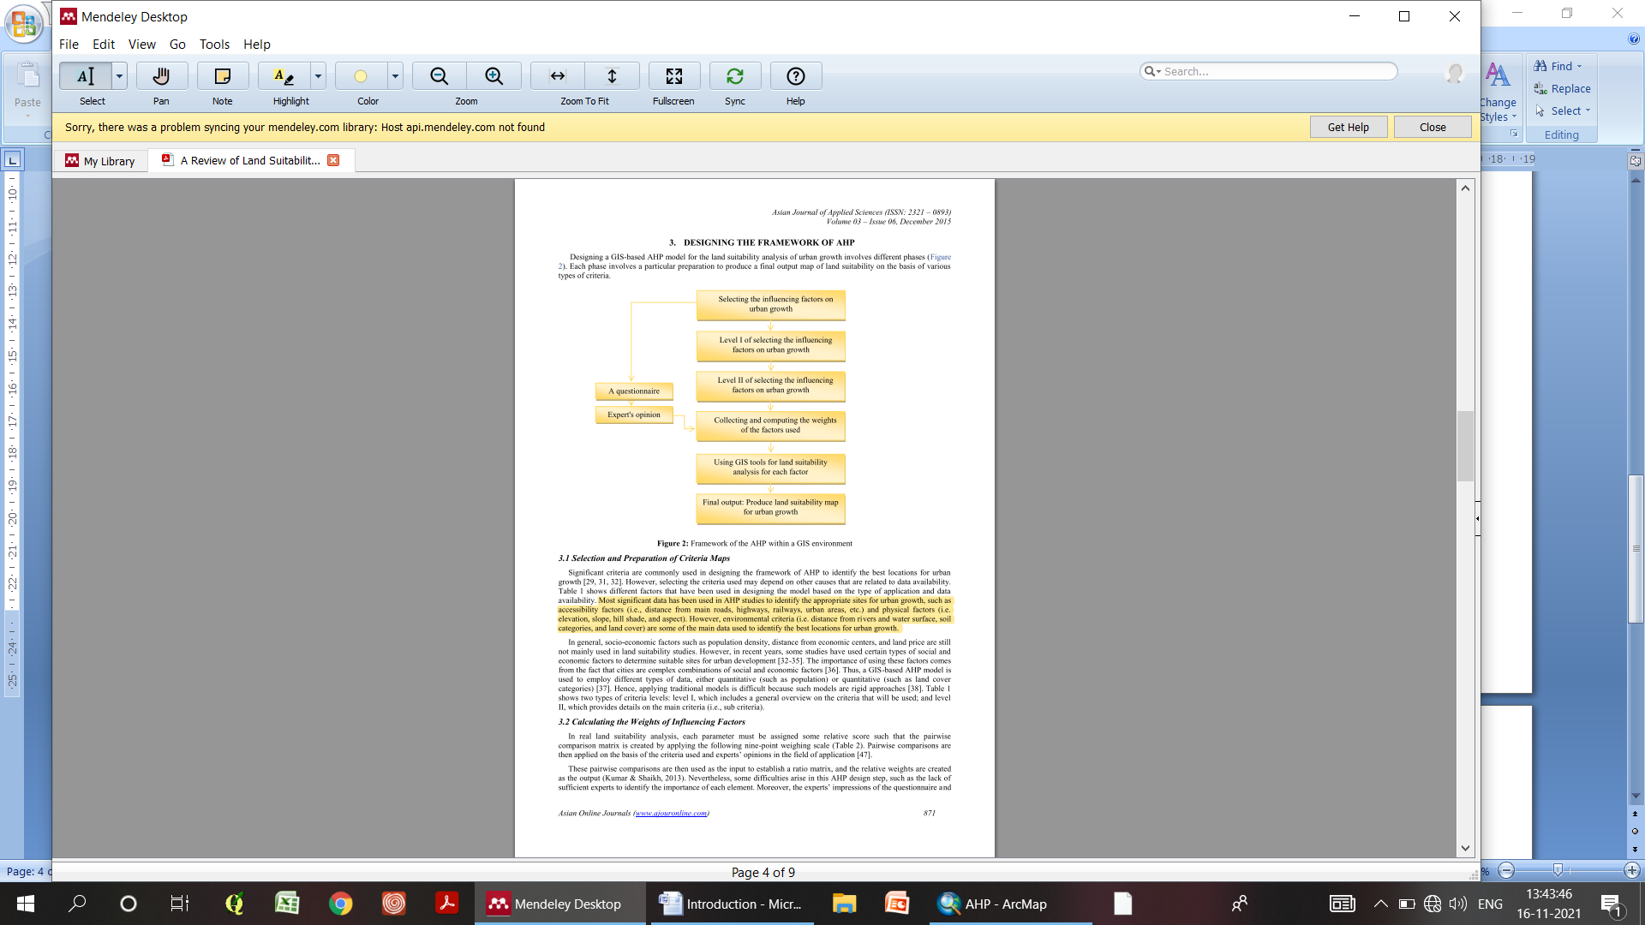The Future success of economic growth policies depends a lot on the infrastructure development. Several decisions taken by different planning agencies require spatial analysis of maps involving many parameters.
* In order to determine the most desirable direction for future development, the land suitability for various land uses should be carefully studied with the aim of directing growth to the most appropriate sites. When we avoid this, we’ll have to face many problems which can be major or minor.

Table 1

* Each phase involves a particular preparation to produce a final output map of land suitability on the basis of various types of criteria.

## STUDY AREA:

The Chennai and Chengalpattu districts were selected as the study area where Chennai is one of the metropolises of India and Chengalpattu is near to the industrial and IT hub. Chennai and Chengalpattu are bounded between the Latitudes and Longitudes 79° 59.328’ E, 12° 40.914’ N and 80° 16.242’ E, 13° 4.9862’ N. Chennai is a low-lying area and the land surface is almost flat but has witnessed tremendous growth in its manufacturing, retail, healthcare and IT sectors in the last ten years. Chengalpattu also called as Chingelput, town which is located along the Palar River, about 35 miles (56km) south –Southeast of the city Chennai. The town is well connected by rail and road with the adjoining urban centers, viz.: Arakkonam, Chengalpattu, Arcot and Vandavasi and one of the upcoming hub for IT sectors and a developing metropolis. As in this study we have taken one of the urbanized area Chennai which we have taken into consideration because of the unplanned or not properly organized urbanization which causes several impacts on this areas whether it may be trivial or essential. The overall conclusion is that the Foundation is not organized. Furthermore, Chengalpattu which is one of the developing IT hubs and in future it may become one of the urbanized area in Tamil Nadu it also need to be considered from the beginning to avoid such issues.

In the present study, the important physical criteria which are considered for the suitability analysis are Slope, Landuse Land cover, Geomorphology, Soil, Distance from amenities like Road and Water bodies for the Suitability. The creation of these criteria has been carried out using remote sensing and GIS techniques. These are taken assigned and weighted individually by using Saaty’s AHP (Analytic Hierarchy Process) method and then stocked in a separated geodata base. Then intergration of these crieteria are merged by using union tool the overall weightages is stored in a separate field.

Figure 1 - Satellite image of the Study area (Source : GoogleEarth)

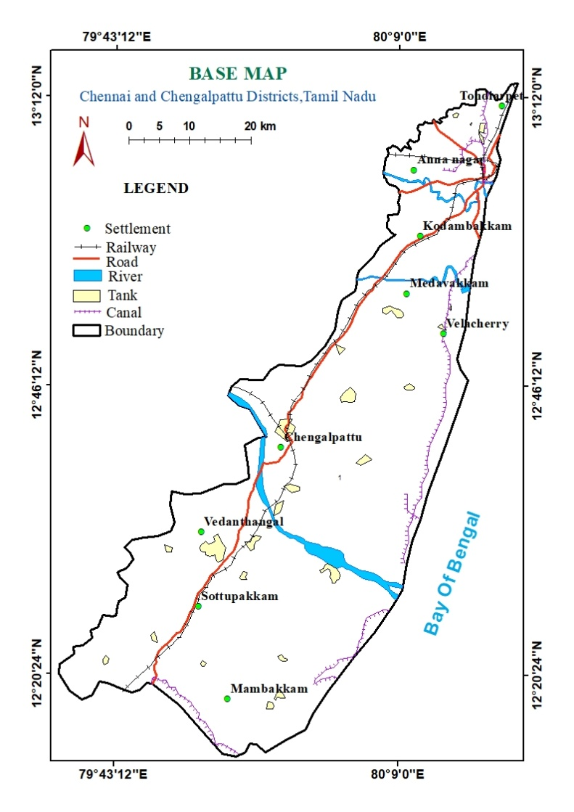

Figure 2 - Base map of the Study area

## DATA SETS AND METHODOLOGY:

The accomplishment of the whole methodology is illustrated in the flowcharts, and the data which we have used is shown below. According to the study area, we need to consider certain criteria’s to facilitate and suggest the suitable areas for sustainable urbanization. In order to derive the suitability map we need many layers which are spatial and non spatial collection of data. Preparation of Thematic layers and the Additional Criteria maps were used. The thematic layers which were taken into consideration are Lithology, Lineament, Geomorphology, Soil, Slope, Aspect, Landuse and Land Cover, Drainage. These were demarcated by using ARCGIS software and ENVI software. The data which we have used are the CARTOSAT DEM with a resolution of 2.5m. It is mainly used to demarcate Slope, Drainage, Aspect, Shaded Relief, and Lineament. Then LandSat -8 OLI data which was taken from USGS with a spatial resolution of 30m was used to demarcate Geomorphology, Landuse and Land cover. The Lithology, Soil map was demarcated by using the Source map from the Geological Survey of India. The additional criteria maps were derived mainly by using the thematic layers. It includes Normalized Difference Water Index, Normalized Difference Built up Index, Ground Water Potential, Ground Water Quality, Distance from Road, Distance from Water Bodies and Soil Moisture Index. Further certain maps are preferably selected and assigned certain weightage values with accordance with selectable knowledge and guidance and then Integration of these layers are done by using Analytic Hierarchy (AHP) Model and thus by using the GIS software the layers are taken and run as Vector based model by assigned weightages to each of the features in the selected layers and the produced map summarizes the Suitable areas for Urbanaization.

|  |  |  |  |  |
| --- | --- | --- | --- | --- |
| **Sl. No** | **Satellite data** | **Date of Acquisition** | **Spatial Resolution** | **Sensor** |
| 1 | Landsat - 8 | 02/04/2020 | 30m | OLI |
| 2 | DEM | 2014 | 2.5m | CartoSat |

Table 2 - Primary Data

|  |  |  |
| --- | --- | --- |
| **Sl.No** | **Reference Map** | **Used for** |
| 1 | SOI Toposheet | Base map |
| 2 | Lithology map - GSI | Lithology map |
| 3 | National Bureau of Soil Survey Soil Map | Soil map |
| 4 | CGWB- Recent Report | GWQ |

Table 3 - Secondary Data

Methodology 1

Methodology 2

# AHP MODELLING:

AHP, which was developed by Saaty, is currently one of the important techniques for analyzing land suitability. AHP is categorized under the multi-criteria decision analysis approach and is an effective technique that helps planners and decision makers to analyze all data before arriving at a final decision for future land-use changes. AHP has been integrated with GIS tools to identify the importance of the criteria used and to calculate weights by using a scale of importance and the opinion of experts. To make a valid suggestion in a proper way to generate precedence we need to make comparative analysis and need a scale of numbers that shows how many times more important or dominant one parameter is over another parameter with respect to the criterion or property they are compared. The Analytic Hierarchy Process (AHP) is a pair wise comparison measurement. Identifying the relative weights of the factors used in land suitability analysis is generally difficult. Thus, the use of a technique that has a powerful capability to identify the weights iss important. AHP is one of the significant techniques used in analyzing issues related to spatial nature. The comparisons are made using a scale of absolute judgments that represents how much more; one element overshadows another with respect to a given attribute. Thus, a GIS-based AHP model is used to employ different types of data, either quantitative (such as distance from road) or quantitative (such as land cover categories).

## INTEGRATION OF GIS DATA AND AHP MODELLING:

In this outlook, several types of GIS functions can be pertained to develop and produce land suitability maps based on AHP. GIS has a significant potential to generate, organize, and layout map layers (raster logic) and conduct quantitative and logic analysis for land suitability processes. However, GIS environments have no ability to determine the relative weights for the criteria used. AHP and multi-criteria models are provided an objective evaluation for the relative weights of each factor. Preparing the analytical layers of influencing factors on land suitability is the first part of the generation process of land suitability maps by using GIS environment. Furthermore, the conversion tool is used to change the format of input data from vector to integer raster format. Moreover, buffer analysis is implemented for each influencing factor to identify the appropriate location for urban growth on the basis of the importance of the distance, density, limitations, etc. Reclassification tool is employed to convert the layers used to either integer or floating raster's based on common scales for land suitability. The calculation tool is then used to compute the weights for each layer on the basis of the AHP procedures.

# DATA BASE GENERATION:

## THEMATIC MAPS:

### LITHOLOGY MAP:

Lithology describes the geochemical, mineralogical and physical properties of rocks. It plays the key role in many processes in earth surface, especially the flexes of matter to soils, ecosystem, rivers and oceans. Lithological mapping is the important parameters for interpretation, identification and mapping of land surface which holds the foundation in the terrain. The data which we have used for the Lithology map is derived from Geological Survey of India. Lithological mapping in the study area defines the characteristics of nature of rock types and their association and formation. The Chennai city Lithology are mostly composed of undifferentiated sediments which many in Fluvial, Aeolian sediments and a small portion of Upper Gondwana Group (Sandstone) and the Chengalpattu Lithology are mostly of Charnokite Gneiss, Migmatite Gneiss.

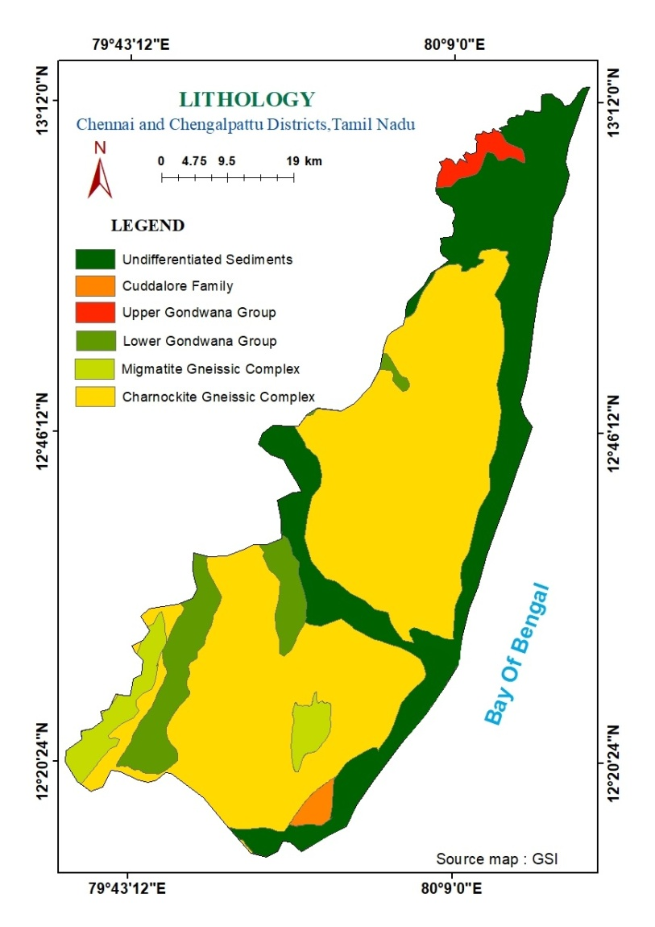

Figure 3 - Lithology map

### SHADED RELIEF MAP:

A raster image is prepared showing changes in elevation using light and shadows on terrain from a given angle and altitude of the light source. Shaded relief maps show features on the surface, such as mountains, valleys, plateaus, and canyons. Areas that are flat or have few features are smooth on the map, whereas areas with steep slopes and mountains appear more rough. The maps were generated using Digital Elevation Model or DEM. The properties of altitude and azimuth together indicate the sun's relative position that will be used for creating any 3D model (hill shade or shaded relief). Altitude is the sun's angle of elevation above the horizon and ranges from 0 to 90 degrees. A value of 0 degrees indicates that the sun is on the horizon, that is, on the same horizontal plane as the frame of reference. A value of 90 degrees indicates that the sun is directly overhead. Azimuth is the sun's relative position along the horizon (in degrees). This position is indicated by the angle of the sun measured clockwise from due North. An azimuth of 0 degrees indicates north, east is 90 degrees, south is 180 degrees, and west is 270 degrees. Various azimuthals (0 – 330) have been tested to clearly visualize the Lineaments by keeping the altitude constant.

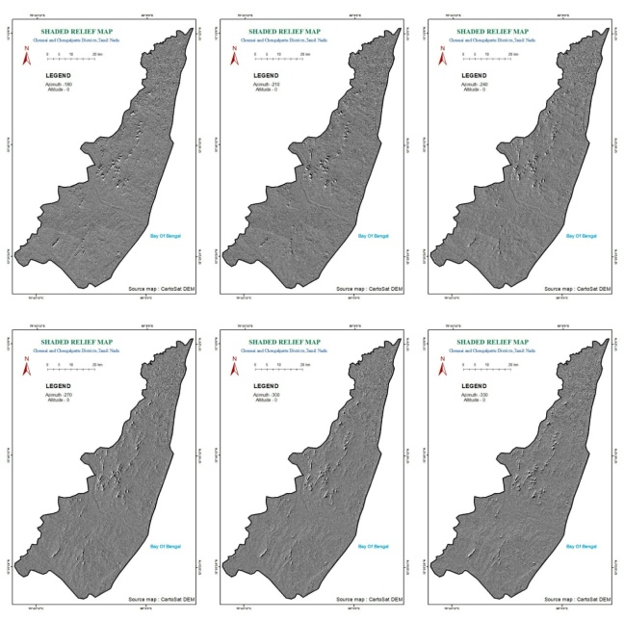

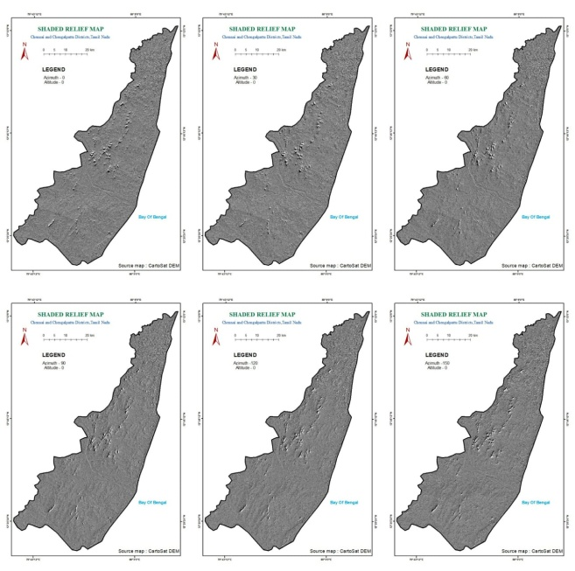

Figure 4 (a) - Shaded Relief Maps

### LINEAMENT AND LINEAMENT DENSITY:

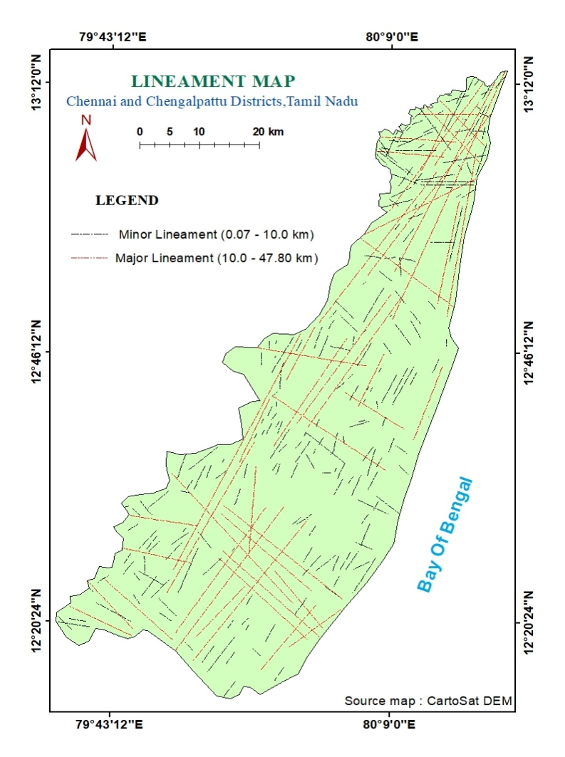Lineaments are straight linear elements visible at the Earth's surface as a significant “lines of landscape”. These are primarily a reflection of discontinuities on the Earth’s surface caused by geological or geomorphic processes. Lineament studies have vast applications in different disciplines of geosciences for example identification of tectonic features, recognition of folds and faults, exploration of mineral deposits, petroleum prospects and groundwater etc. Remote sensing data i.e. CartoSat DEM images of an area are useful to map lineaments. For better interpretation of lineaments, the images are digitally processed using shaded relief maps, satellite data. Further high spatial resolution and multi-spectral data (with colour composites suitable for particular application) make the marking of lineaments much easier, accurate and reliable. Lineament map has been prepared using Cartosat DEM data which was further enhanced using SRM (shaded relief map ) with different sun elevation and azimuth angles ( sun elevation 0, 30, 60, 90, 120, 150, 180, 210, 240, 270, 300, 330 and the azimuth are 30 degree). The study area is covered by major and minor lineaments. The lineaments that more than ten (10) km long are classified as **major lineaments** and <10 km long lineaments are **minor lineaments**.

Figure 5 - Lineament map

The lineament map is then converted into zones of different lineament density. Lineament density map is a measure of quantitative length of linear feature expressed in (km/1km2). Lineament density of an area has direct influence on groundwater occurrence of that area. In this study area lineaments are almost in all directions and largely on Southeast to Northwest direction and Northwest to Southeast directions. In lineament density influence more on ground water. Lineament analysis in Chennai and Chengalpattu area has been performed for Groundwater exploration.

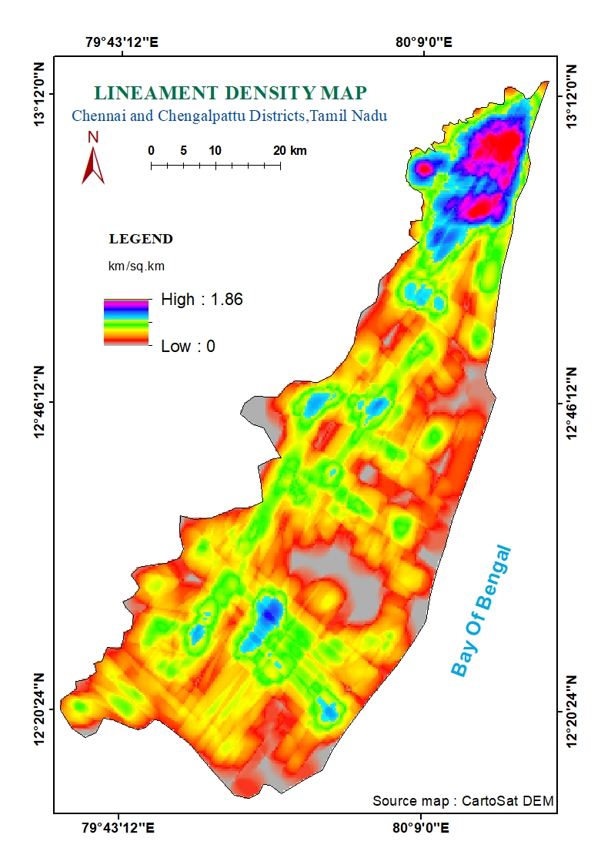

Figure 6 - Lineament Density

### GEOMORPHOLOGY:

A Geomorphological map portrays surficial features or landforms that record geologic processes on the earth's surface. Geomorphology is the study of landforms form on the earth, its description and genesis. It is a branch of earth science, which has grown after the advent of aerial photographs and satellite data. The geomorphology exercises a significant control over the Site suitability analysis Geomorphology, along with information on soil, water and vegetation has become one of the essential inputs in planning for various developmental activities. Geomorphology of an area depends upon the structural evolution of geological formation. Geomorphology reflects various land form and structural features. The synoptic view of satellite data provide a wealth of information about configuration of various landforms, probable recharge and discharge characteristics based on varied spectral signatures. The various geomorphic units delineated from satellite data in the study area are described and presented in this Geomorphology map. The study area is majorly covered with pediplain and pediments. The other geomorphic features interpreted and mapped in our study area are: Residual Hills, Inselberg, Linear Ridge, Colluvial Fill, Older Flood Plain, Younger Flood Plain, Older deltaic plain, Younger Deltaic Plain, Older coastal plain, Tidal flat, Back water, Marsh, Beach Ridge, Sand Dunes, Creek, Estuarine Islands, Channel Island, Swales and Beaches. Geomorphology plays a vital role and an important layer which is taken into consideration of both Ground water Potential and Urbanization process for the selection of land surface and suitability.

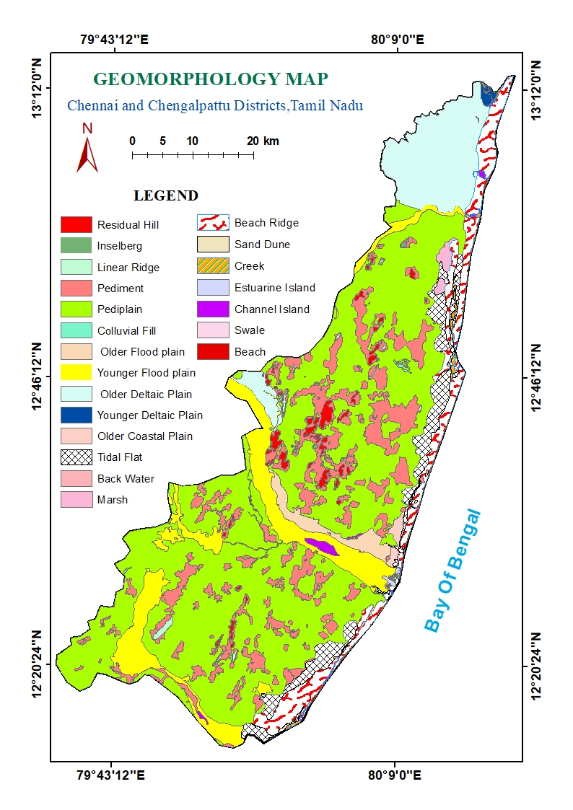

Figure 7 - Geomorphology map

### SLOPE :

|  |  |  |
| --- | --- | --- |
| THEMATIC MAP | CLASSES | CLASSIFICATION |
| SLOPE MAP | 0 - 1 | Nearly Early Level |
| 1-2 | Very Gently Sloping |
| 2-4 | Gently Sloping |
| 4-8 | Moderately Sloping |
| 8-13 | Strongly sloping |
| 13-20 | Steep Sloping |
| 20->30 | Very Steep Sloping |

A slope map is a topographic map showing changes in elevation on a highly detailed level. It is one of the important terrain parameters which are explained by horizontal spacing of the contours. The slope map places an important role in road alignment and for the suitability of a land surface. The aslope values are calculated in either in percentage or degree in both vector and raster forms Architects, landscape designers, and water control planners use a slope map to evaluate a particular site. Detailed data are required to generate one of these maps. Chennai is a flat lying area. In this slope map the nearly level ranges from zero to one percentage and the very steep slope range from 30%. It is categorized by using IMSD classification. In our study area Chennai is mostly covered with Nearly level (0-1), Very gently slope (1-2) and Gently sloping (2-4) whereas Chengalpattu ranges from Nearly level to Very steep sloping. The above the Palar River mostly consists of Strongly sloping steep.

Table 4

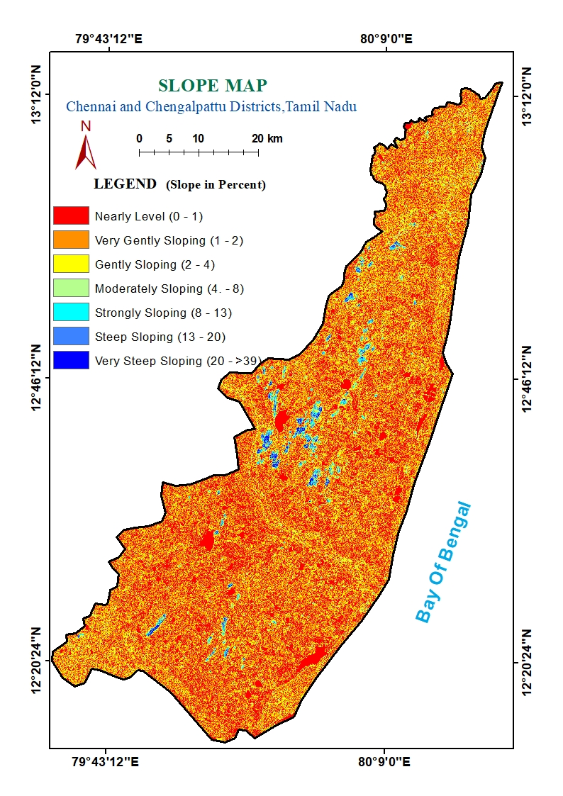

Figure 8 - Slope map

### SLOPE ASPECT :

An aspect-slope map overlays the elevation information with aspect information. These maps are used to visualize the views of the future occupants of a building. The Aspect refers to the compass direction that a hillside or slope faces. A southern aspect is the same as a south-facing slope. Many geographic information systems (GIS) can analyze digital elevation data (elevation points, contour lines, digital elevation models, etc.) and derive both slope and aspect data sets. The degree to which sunlight strikes a hillside depends on its aspect; north-facing hillsides receive little or no sunlight; east- and west-facing slopes receive sunlight for a portion of each day (unless they are shaded by another hill or mountain); and south-facing slopes receive the greatest amount of sunlight. Because aspect affects the amount of sunlight striking the land's surface, aspect can be an important metric that aids in the sitting of buildings to maximize or minimize solar gain. Aspect also can be one of a number of determinants of vegetation communities, habitat, soil moisture, evapotranspiration, and other biological and physical landscape characteristics.

|  |  |  |
| --- | --- | --- |
| THEMATIC MAP | DIRECTION | VALUES |
| ASPECT MAP | Flat | -1 |
| North | 0-22.5 |
| North East | 22.5-67.5 |
| East | 67.5-112.5 |
| South East | 112.5-157.5 |
| South | 157.5-202.5 |
| South West | 202.5-247.5 |
| West | 247.5-292.5 |
| North West | 292.5-337.5 |
| North | 337.5-360 |

Table 5

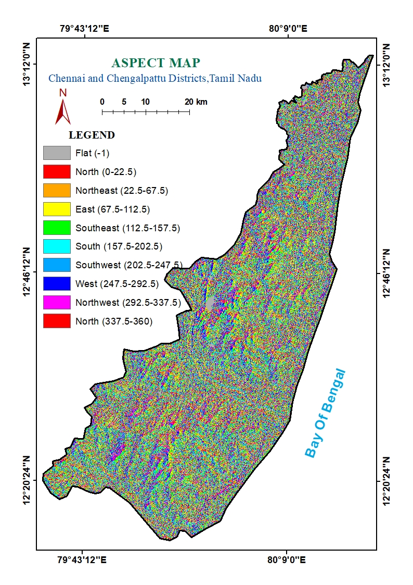

Figure 9 - Aspect map

### DRAINAGE AND DRAINAGE DENSITY :

The drainages of our study were delineated using CARTOSAT DEM data, which has a spatial resolution of 15m and corrected using SOI toposheets. The availability of nearby water bodies are mapped for water supply to the residences. At the same time, the drainages, canals and static water bodies should be kept free and without encroachments so as to avoid the negative effect on urban growth because they cause flash floods from time to time. Hence they are treated as restricted areas for urban and industrial development.

Drainage density has long been considered a fundamental watershed property to describe how well or how poorly a watershed is drained by stream channels. Drainage Density is significant and it plays an important role in surface-runoff processes, influencing the intensity of torrential floods, the concentration, the sediment load and even the water balance in a drainage basin. Areas with low drainage density indicate comparatively higher infiltration and low runoff. The zones with low to moderate drainage density are considered excellent groundwater potential zones and were assigned a weightage of 0.10.

Rainfall is a primary source of water for groundwater recharge in this area. In the Drainage density map the drainage density was classified into 5 classes. The Dark blue region indicates high drainage density and the Yellow region indicates Low Drainage Density. The Drainage density is considerably high near Palar river region. Most of the regions as drainage density between 1.07 to 1.3 km /sq km. which is shown in lighter green color.

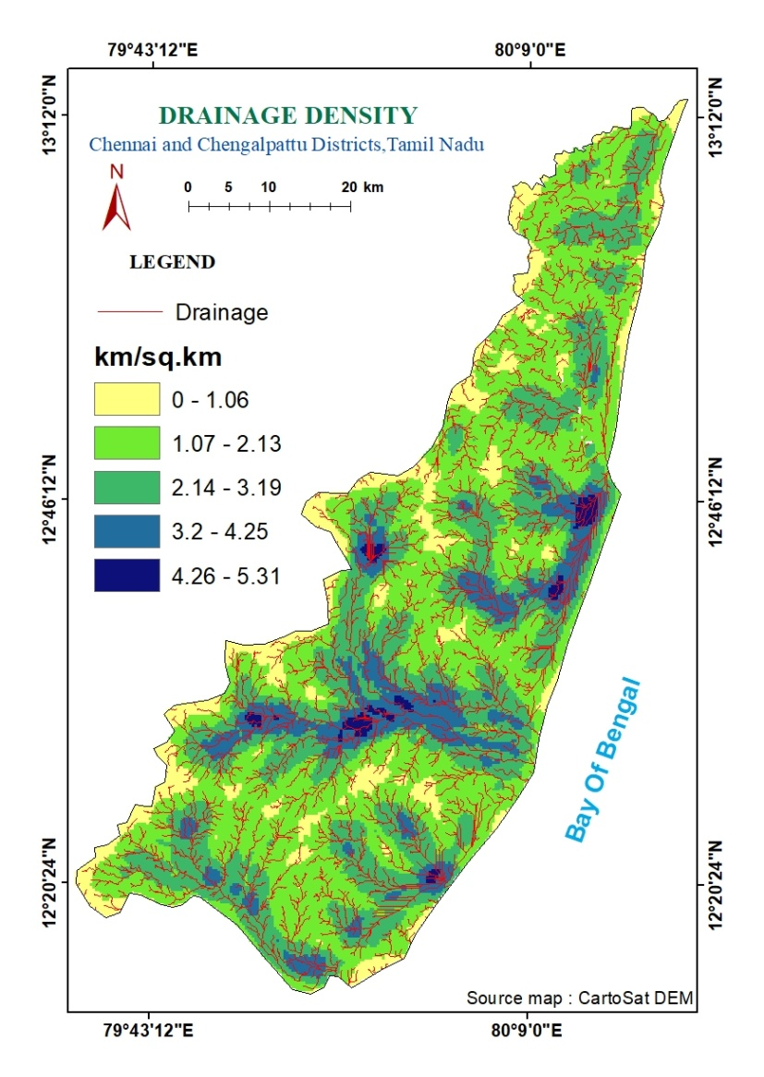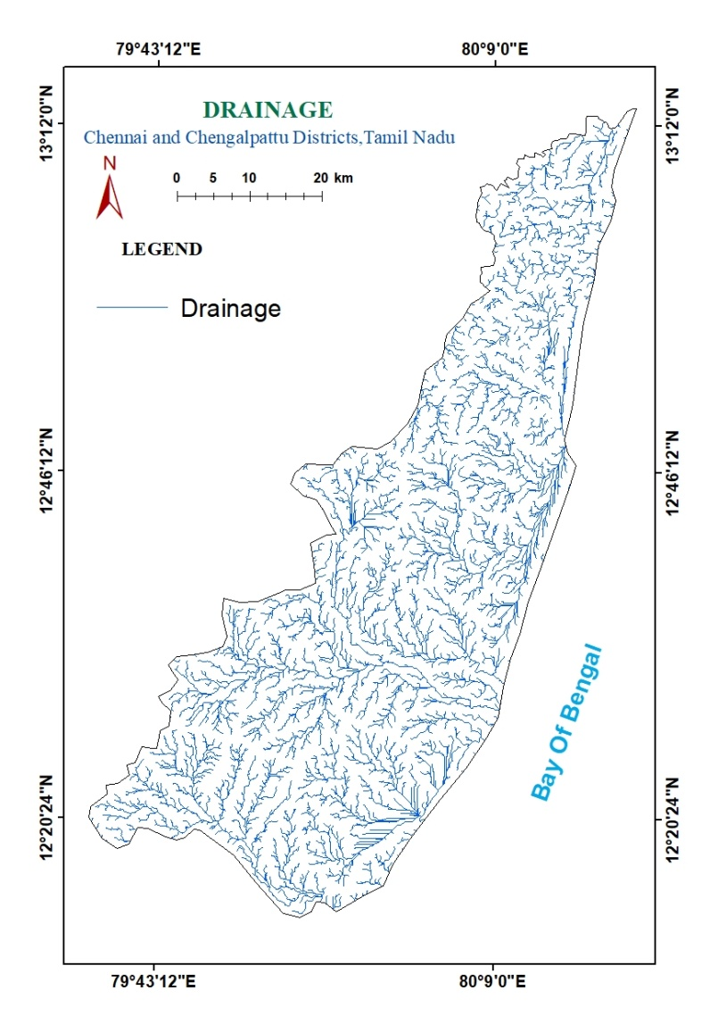

Figure 10 - Drainage and Drainage Density

### LANDUSE AND LAND COVER :

Land cover refers to the surface cover on the ground, whether vegetation, urban infrastructure, water, bare soil or other. Identifying, delineating and mapping land cover is important for global monitoring studies, resource management, and planning activities. This classification system was specially developed by Space Application Centre for the purpose of land use planning. Identification of land cover establishes and provides the ground cover information for baseline thematic maps. Land use refers to the purpose the land serves, for example, recreation, wildlife habitat, or agriculture. It is mainly used to know the current quantity of land is in what type of use and to identify the land use changes from year to year. This knowledge will help develop strategies and for planning several methods for the sustainable development.

Land cover / use studies are multidisciplinary in nature. In addition to facilitating sustainable management of the land, land cover and use information may be used for planning, monitoring, and evaluation of development, industrial activity, or reclamation. Land use classification of the specified area using remotely sensed data. Land use is obviously constrained by environmental factors such as soil characteristics, climate, topography and vegetation. But, it also reflects the land as a key and finite resource for most human activities including agriculture, industry, forestry, energy, production, settlement, recreation and water catchments and storage.

In this study area the Land use has been classified based on NRSC Level-2 classification and it includes Settlements, Industrial Land, Crop Land, Fallow Land, Agricultural Plantation, Scrub Forest, Land with Scrub, Land without Scrub, Barren Rocky, Marshy Land, Salt Pan, Rivers, Tanks.

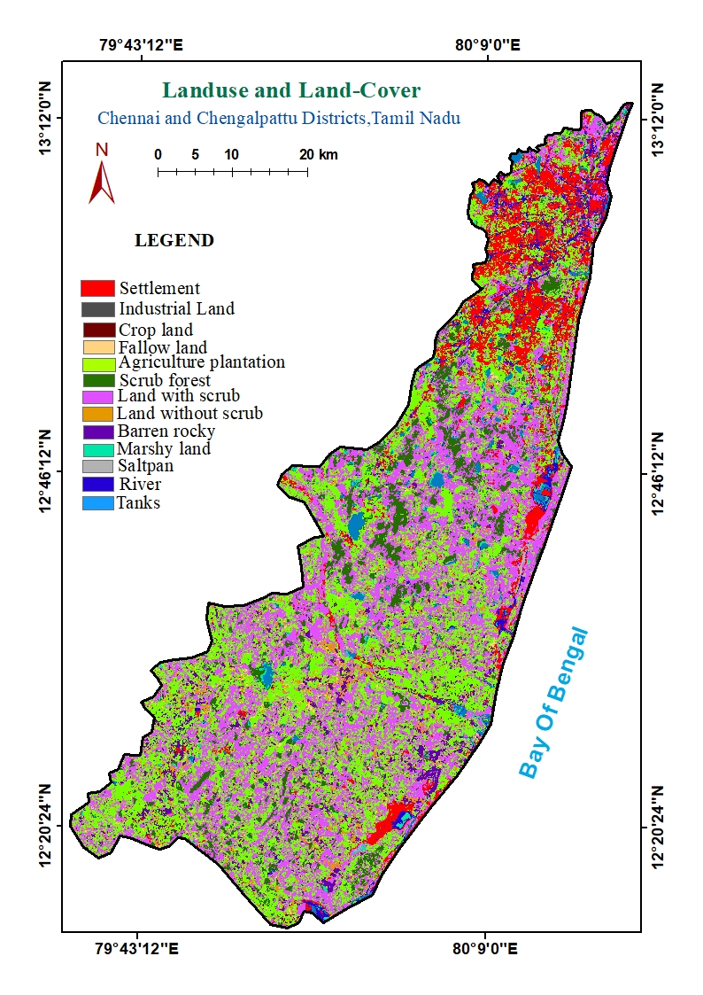

Figure 11 - LULC map

### SOIL

Soil map is a geographical representation showing diversity of soil types and/or soil properties in the area of interest. It is typically the end result of a soil survey inventory, i.e. Soil survey. Our study areas consist of mainly Very Deep Cracking Clayey soil, Moderately deep Gravelly Clay soil and Deep calcareous clayey soil. Along the coastal side our study area consist of Periodically Flooded area, Very Deep Sandy soil and Deep Clayey soil. The Palar River is surrounded with very deep calcareous clayey soil.

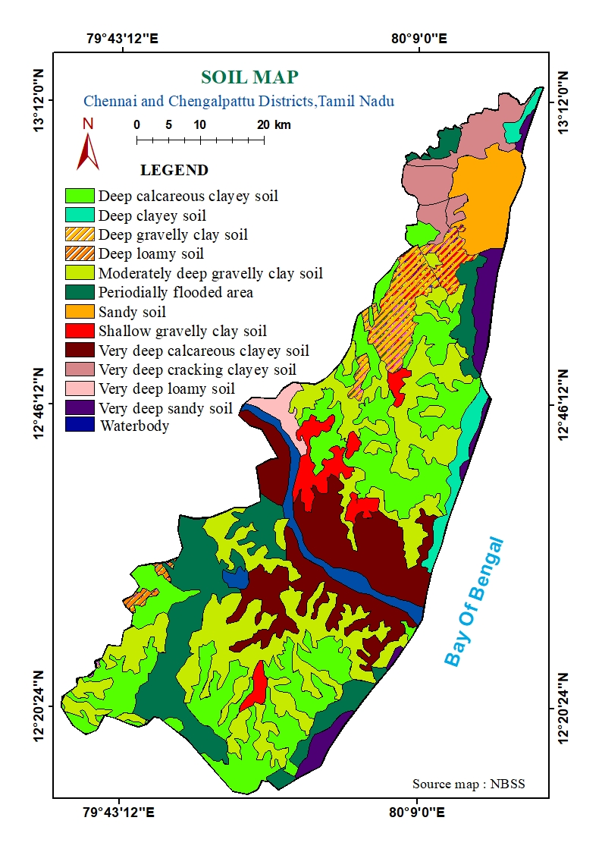

Figure 12 - Soil map

## ADDITIONAL CRITERIA MAPS:

### NDBI:

NDBI is the most common index used for analysis the built-up areas. It requires composite band & apply numbers of operation for the final result. The accuracy derived from image classification technique depends on the image analyst & method followed by analyst. However, NDBI calculation is simple and easy to derive. The Normalized Difference Built-up Index (NDBI) uses the NIR and SWIR bands to emphasize built-up areas.

For LANDSAT 8 data,

**NDBI = (Band 6 – Band 5) / (Band 6 + Band 5).**

Also, the Normalize Difference Build-up Index value lies between -1 to +1. Negative values of NDBI represent water bodies where as higher values represent build-up areas. NDBI value for vegetation is low.

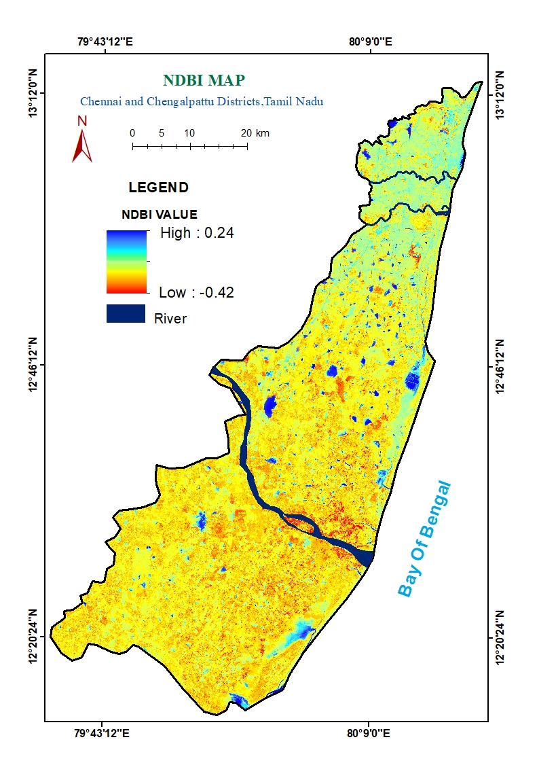

Figure 13 - NDBI map

### NDWI:

The Normalized Difference Water Index (NDWI) is a satellite-derived index from the Near-Infrared (NIR) and Short Wave Infrared (SWIR). The Normalized Difference Water Index (NDWI) is a new method that has been developed to delineate open water features and enhance their presence in remotely-sensed digital imagery. It enhances the water information effectively in most cases. It is sensitive to built-up land and often results in over-estimated water bodies. This index uses the near infrared (NIR) and the Short-Wave infrared (SWIR) bands.

NDWI can be calculated by following formula:

**NDWI = (NIR – SWIR) / (NIR + SWIR)**

For Landsat 8 data,

**NDWI = (Band 5 – Band 6) / (Band 5 + Band 6)**

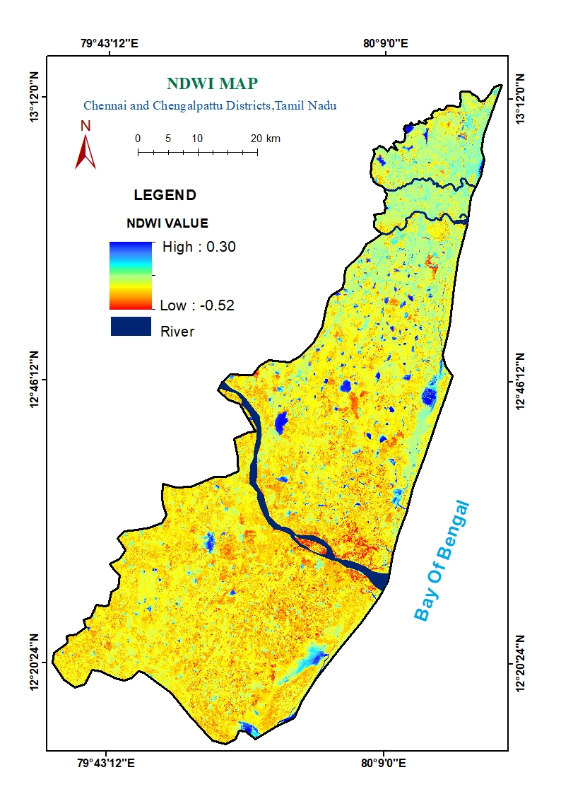

Figure 14 - NDWI map

### SMI:

The soil moisture index (SMI) is defined as the proportion of the difference between the current soil moisture and the permanent wilting point to the field capacity and the residual soil moisture. The index values range from 0 to 1 with 0 indicating extreme dry conditions and 1 indicating extreme wet conditions. The Soil Water Index quantifies the moisture condition at various depths in the soil. It is mainly driven by the precipitation via the process of infiltration. Soil moisture is a very heterogeneous variable and varies on small scales with soil properties and drainage patterns. Satellite measurements integrate over relative large-scale areas, with the presence of vegetation adding complexity to the interpretation. This soil moisture index map is categorized into Very Low, Low, Medium, High and Very High.

**SMI = (LSTmax – LST) / (LSTmax – LSTmin)**

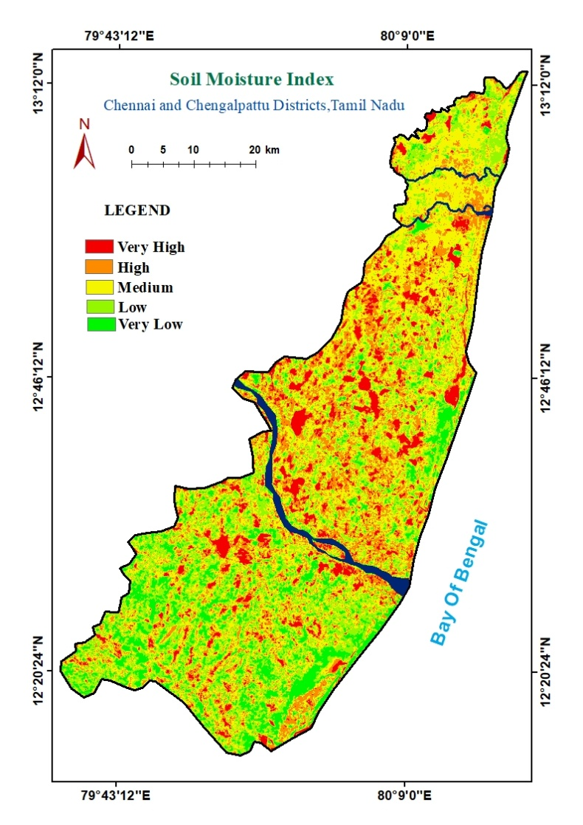

Figure 15 - Soil Moisture Index

### GROUND WATER QUALITY:

Groundwater quality refers to the state of water that is located beneath Earth's surface. The quality of groundwater is important because it determines the suitability of water for drinking, and domestic and irrigation purposes. Monitoring of ground water quality is an effort to obtain information on chemical quality through representative sampling in different hydrogeological units. The chemical quality is being monitored by Central Ground Water Board once in a year through observation wells located all over the country, in regular monitoring programme. Apart from these observation wells the quality is also monitored through various studies like ground water management studies, ground water exploration etc. The ground water monitoring activity is aimed at generating background data of different chemicals constituents in Ground water on a regional scale. A groundwater quality study was carried out at 26 well sampling from the Central Ground Water Bodies (CGWB). The report which was used for the preparation of Quality was 2018. The eight parameters are Dissolved Oxygen (DO), Electrical Conductivity (EC), Total Dissolved Solids (TDS), salinity, pH, turbidity, Total Suspended Solids (TSS), chloride and other parameter is depth to groundwater level. Groundwater samples were obtained from each well. And further process has done through GIS techniques.

Further, it has classified into five class based on the parameters from Very High, High, Moderate, Low and Very low. The groundwater in Very High quality zones are potable and very low indicates the not potable. Chennai area is mostly covered by very low and low potable categories and Chengalpattu region covered by high groundwater quality zones. It gives us a basic idea on the Portability of the water resource and acts as a correlative map in this study in Land suitability.

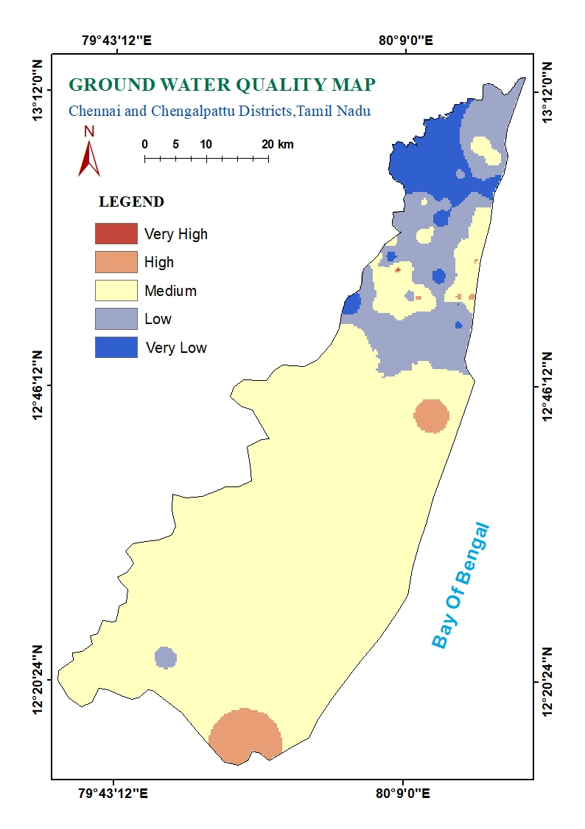

Figure 16 - Ground Water Quality

### GROUND WATER POTENTIAL:

Groundwater plays an important role in global climate change and satisfying human needs.

The relative importance of various thematic layers and their corresponding classes were used for generating the groundwater potential zone map. The Rank and Weightage of individual thematic layers and the mean and standard deviation of CSI for arriving at the groundwater potential map are given below accordingly.

**Overall Weightage**

|  |  |  |  |  |  |  |  |  |
| --- | --- | --- | --- | --- | --- | --- | --- | --- |
| **Factors** | Lithology | LD | GM | Soil | Slope | LULC | DD | Weight |
| Lithology | 7 | 6 | 5 | 4 | 3 | 2 | 1 | 0.38 |
| LD | 7/2 | 6/2 | 5/2 | 4/2 | 3/2 | 2/2 | 1/2 | 0.19 |
| GM | 7/3 | 6/3 | 5/3 | 4/3 | 3/3 | 2/3 | 1/3 | 0.12 |
| Soil | 7/4 | 6/4 | 5/4 | 4/4 | 3/4 | 2/4 | 1/4 | 0.10 |
| Slope | 7/5 | 6/5 | 5/5 | 4/5 | 3/5 | 2/5 | 1/5 | 0.08 |
| LULC | 7/6 | 6/6 | 5/6 | 4/6 | 3/6 | 2/6 | 1/6 | 0.066 |
| DD | 7/7 | 6/7 | 5/7 | 4/7 | 3/7 | 2/7 | 1/7 | 0.064 |
| Total | | | | | | | | 1 |  |

1. **Lithology**

|  |  |  |  |
| --- | --- | --- | --- |
| **Factors** | **Weightage to Layer** | **Weightage to Features** | **Overall** |
| **Lithology** | | | |
| Charnokite Gneiss | 38 | 1 | 38 |
| Migmatite Gneiss Complex – Fresh | 1 | 38 |
| Lower Gondwana Group – Shale | 2 | 76 |
| Upper Gondwana Group – Sandstone | 4 | 152 |
| Cuddalore family | 5 | 190 |
| Undifferentiated Sediments | 5 | 190 |

1. **Geomorphology**

|  |  |  |  |
| --- | --- | --- | --- |
| **Factors** | **Weightage to Layer** | **Weightage to Features** | **Overall** |
| **Geomorphology** | | | |
| Residual Hill | 12 | 1 | 12 |
| Insel Berg | 1 | 12 |
| Linear Ridge | 1 | 12 |
| Pediment | 1 | 12 |
| Pediplain | 3 | 36 |
| Colluvial Fill | 4 | 48 |
| Older Flood Plain | 5 | 60 |
| Younger Flood Plain | 5 | 60 |
| Older Deltaic Plain | 5 | 60 |
| Younger Deltaic Plain | 5 | 60 |
| Tidal Flat | 2 | 24 |
| Back Water | 2 | 24 |
| Marsh | 2 | 24 |
| Beach Ridge | 4 | 48 |
| Coastal Sand Dunes | 3 | 36 |
| Creek | 3 | 36 |
| Estuarine Island | 3 | 36 |
| Channel Island | 3 | 36 |
| Swale | 2 | 24 |
| Beach | 3 | 36 |

1. Soil

|  |  |  |  |  |  |
| --- | --- | --- | --- | --- | --- |
| **Factors** | **Weightage to Layer** | | **Weightage to Features** | **Overall** | |
| **Soil** | | | | | |
| Water Body | 10 | 5 | | | 50 |
| Deep Calcareous Clayey Soil | 3 | | | 30 |
| Deep Clayey Soil | 1 | | | 10 |
| Deep Gravelly Clay Soil | 3 | | | 30 |
| Deep Loamy Soil | 2 | | | 20 |
| Moderately Deep Gravelly Clayey Soil | 3 | | | 30 |
| Periodically Flooded Area | 2 | | | 20 |
| Sandy Soil | 5 | | | 50 |
| Shallow Gravelly Clay Soil | 4 | | | 40 |
| Very Deep Calcareous Clayey Soil | 1 | | | 10 |
| Very Deep Cracking Clayey Soil | 1 | | | 10 |
| Very Deep Loamy Soil | 1 | | | 10 |
| Very Deep Sandy Soil | 5 | | | 50 |

1. Slope

|  |  |  |  |  |
| --- | --- | --- | --- | --- |
| **Factors** | **Weightage to Layer** | **Weightage to Features** | | **Overall** |
| **Slope** | | | | |
| 0 –1 | 8 | 5 | 40 | |
| 1 – 2 | 4 | 32 | |
| 2 – 3 | 3 | 24 | |
| 3 – 4 | 2 | 16 | |
| >5 | 1 | 8 | |

1. LULC

|  |  |  |  |
| --- | --- | --- | --- |
| **Factors** | **Weightage to Layer** | **Weightage to Features** | **Overall** |
| **LULC** | | | |
| Settlements | 6.6 | 1 | 6.6 |
| Industrial area | 1 | 6.6 |
| Scrub forest | 2 | 13.2 |
| Crop field | 5 | 33 |
| Fallow land | 5 | 33 |
| Agricultural plantation | 4 | 19.8 |
| Land with scrub | 3 | 26.4 |
| Land without scrub | 2 | 13.2 |
| Barren rocky | 1 | 6.6 |
| Marshy land | 2 | 19.8 |
| Salt pan | 2 | 13.2 |
| River | 5 | 33 |
| Tanks | 5 | 33 |

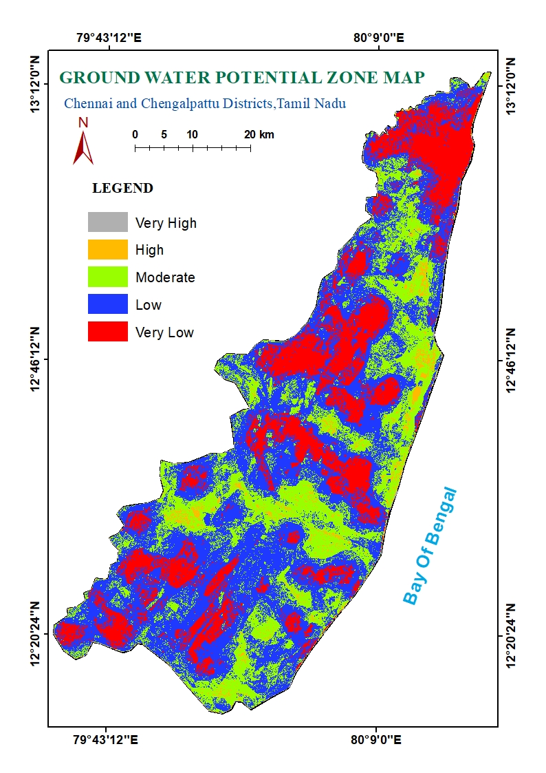

Figure 17 - Ground Water Potential zone

### DISTANCE FROM WATER BODIES:

The urban spreading in proportion to population growth render severe pressure on urban water bodies impairing their absorption capacity, deteriorating water quality, disturbing aquatic biodiversity and finally resulting in the water body vanishing. Hence a complete and proper urbanization process may not be occurred without the existence water bodies. Urbanization should be planned and executed in such a manner that high priority is accorded to local water availability as well its appropriate uses. Urbanisation should approach water-centric expansion that leads balanced natural growth to cities. Throughout the world, urban water bodies like ponds, lakes and reservoirs are the first victims of water pollution from sewage. Due to rapid urbanisation the water bodies are facing severe environmental degradation on account of (a) population explosion, (b) large scale industrialization, (c) chemical intensive agriculture, and (d) water intensive lifestyles. The factors that lead to degradation of water bodies include urbanization, pollution of water due to sewage, nutrient rich agricultural run-off and industrial toxic liquid waste and reclamation leading to siltation. It is therefore required to take optimum caution in handling the water bodies while moving on an urban expansion programme. Proper management should be outlines to preserve the existing water bodies and opt for the new ones in future city planning. In order to facilitate the needs of the people, buffer has done for the surrounded water bodies from the range of 500 m, 1000 m, 1500 m, 2000 m and 2500 m. These are allocated for the betterment and to reduce the inconvenient for the people for the Land Suitability. It is also taken as one of the factor.

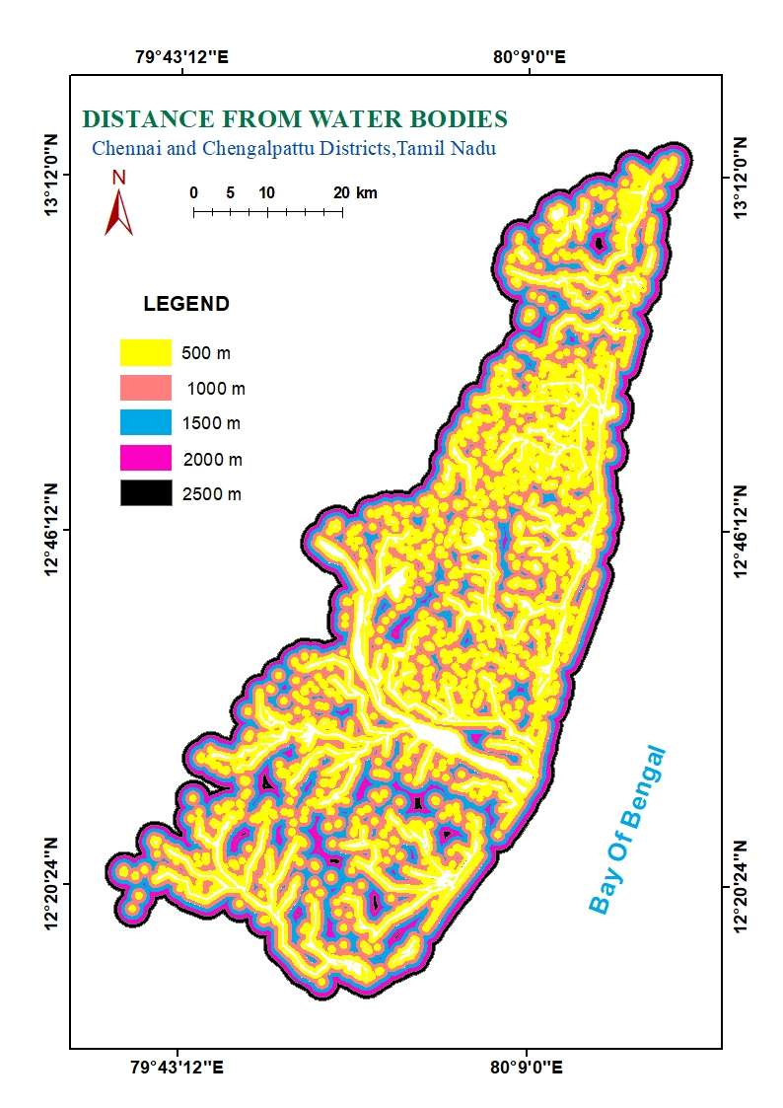

Figure 18 - Distance from Water Bodies

### DISTANCE FROM ROADS:

The urban growth has a mass increase in both Chennai and Chengalpattu. Due to that the existing demand of basic amenities for which they are becoming scarce day by day. The living style and facilities are certainly far better than that of the rural areas. That is why the urbanization is getting triggered off by the surrounding immigrants. The urban population growth primarily by this means helps in spreading out the urban nucleus at the fastest rate. Road is also an important criterion in site suitability because of the need to transport raw products and finished materials. Therefore, effort is made to locate the site nearer to any existing road if possible. Moreover, in order to find out better accessibility to the existing road, buffer zones have been created by taking 500 m, 1000 m, 1500 m, 2000 m, 2500 m. The buffer zone was created using the Multiple Ring Buffer tool in the Analysis Tools It shows the buffer zones and their intensity of importance for road proximity criteria.

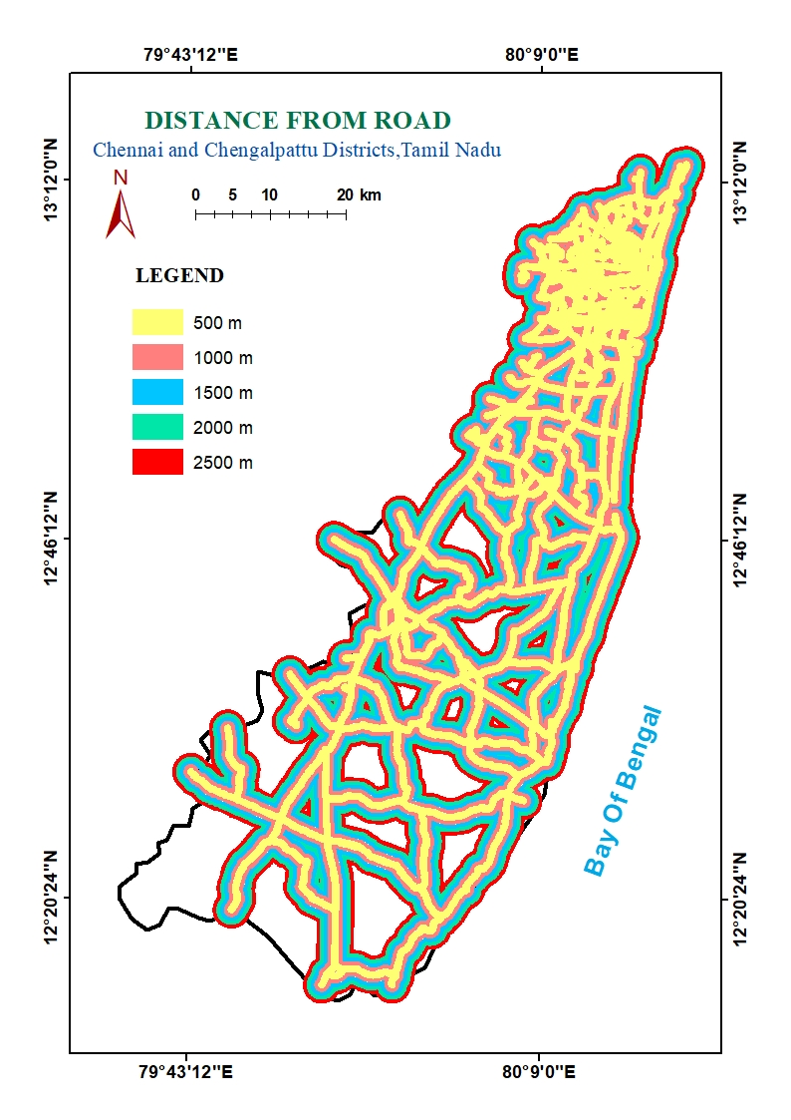

Figure 19 - Distance from Road

# RESULTS AND DISCUSSIONS:

## INTERGRATION OF MAPS AND PREPARATION OF FINAL SUITABILITY MAP:

In this study seven layers were selected particularly such as Geomorphology, Soil, Ground Water Potential, Distance from Road, Distance from Water Bodies, Landuse and Land cover and Slope. These layers were used in the preparation of criteria maps. For suitability analysis it is necessary to give some score to each of the criteria as per their suitability for urban development. For this purpose the pair-wise comparison matrix using different criteria are required to create a ratio matrix. These pair wise comparisons are taken as input and relative weights are produced as an output. After the formation of pair wise comparison matrix, computation of the criterion weights has been done. Each layers were converted into vector data environment for further analysis. After vectorization, these classified vector maps were integrated and assigned weightages accordingly. To assign the Weightages (1, 2, 3, 4 and 5) and Rank for each layers, according to the importance of geological criteria for urbanization, the high weightage for Geomorphology and low weightage for slope have been assigned and reclassified into five classes as Very High, High, Medium, Low and Very Low and converted from raster to vector.

|  |  |  |  |  |  |  |  |  |
| --- | --- | --- | --- | --- | --- | --- | --- | --- |
|  | GM | Soil | GWPZ | DFR | DFWB | LULC | Slope | Overall |
| GM | 7 | 6 | 5 | 4 | 3 | 2 | 1 | 0.38 |
| Soil | 7/2 | 6/2 | 5/2 | 4/2 | 3/2 | 2/2 | 1/2 | 0.19 |
| GWPZ | 7/3 | 6/3 | 5/3 | 4/3 | 3/3 | 2/3 | 1/3 | 0.12 |
| DFR | 7/4 | 6/4 | 5/4 | 4/4 | 3/4 | 2/4 | 1/4 | 0.10 |
| DFWB | 7/5 | 6/5 | 5/5 | 4/5 | 3/5 | 2/5 | 1/5 | 0.08 |
| LULC | 7/6 | 6/6 | 5/6 | 4/6 | 3/6 | 2/6 | 1/6 | 0.066 |
| Slope | 7/7 | 6/7 | 5/7 | 4/7 | 3/7 | 2/7 | 1/7 | 0.064 |
|  | | | | | | | | 1 |

### GEOMORPHOLOGY:

The geomorphology map has been prepared by visual interpretation of satellite FCC, 3D visualized DEM wrapped FCC and digitally processed data. We have given a high rank on Geomorphology because the our study are mostly covered by coastal region and river region. The land suitability is mostly based on geomorphology. Our study area mostly covered by pediplain and also covered by Older deltaic plain, Back water, Beach, and Beach ridge, Channal island , Colluvial fill, Older Coastal plain , Older and younger Deltaic plain, creek, Estuarine island, Inselberg, linear ridge, Marsh, Pediment, Pediplain, Residual Hill, Sand Dune , Swale, Tital flat and Younger flood plain. The high weightage for Pediplain for to construct the building or urban development this feature is more suitable when compare to other feature and lower weightage for Swale, Marsh, Back water, Beach ridges and Beach they not suitable for any constructions and urbanization.

|  |  |  |  |  |  |  |  |  |
| --- | --- | --- | --- | --- | --- | --- | --- | --- |
| **Factors** | **Weightage to Layer** | **Weightage to Features** | **Overall** |  |  |  |  |  |
| **Geomorphology** | | | |  |  |  |  |  |
| Residual Hill |  | 4 | 152 |  |  |  |  |  |
| Insel Berg |  | 4 | 152 |  |  |  |  |  |
| Linear Ridge |  | 4 | 152 |  |  |  |  |  |
| Pediment |  | 2 | 76 |  |  |  |  |  |
| Pediplain | 38 | 5 | 190 |  |  |  |  |  |
| Colluvial Fill |  | 5 | 190 |  |  |  |  |  |
| Older Flood Plain |  | 4 | 152 |  |  |  |  |  |
| Younger Flood Plain |  | 4 | 152 |  |  |  |  |  |
| Older Deltaic Plain |  | 4 | 152 |  |  |  |  |  |
| Younger Deltaic Plain |  | 4 | 152 |  |  |  |  |  |
| Tidal Flat |  | 1 | 38 |  |  |  |  |  |
| Back Water |  | 1 | 38 |  |  |  |  |  |
| Marsh |  | 1 | 38 |  |  |  |  |  |
| Beach Ridge |  | 1 | 38 |  |  |  |  |  |
| Coastal Sand Dunes |  | 3 | 114 |  |  |  |  |  |
| Creek |  | 1 | 38 |  |  |  |  |  |
| Estuarine Island |  | 1 | 38 |  |  |  |  |  |
| Channel Island |  | 1 | 38 |  |  |  |  |  |
| Swale |  | 1 | 38 |  |  |  |  |  |
| Beach |  | 2 | 76 |  |  |  |  |  |

### SOIL:

The Soil is second more important layer for land suitability because the construction basement based on the soil types. The soil map was digitized using the map published by the Soil Survey and Landuse Organization. The soils are classified based on porosity, permeability and size of the particle, into three types, such as sand, silt, and clay. They loamy soil contains equal amount of these three type of soil.

The sandy soil is more suitable for site selection because it provides a strong basement and coarse grain sizes, our study area covered by 14 types of difference soil. The sandy area is high infiltration and low run off so the flood is not occur and it’s has a good Ground Water Potential zone. The clay is not suitable for construction or any other development, It’s have a sliding nature and load is increase and the building going in downward, it does not allow the water so it has a high run off and low infiltration. Moreover this area may have a low ground water recharge potential zone, and not safe for development. The loamy soil is also having strength for urban developments.

We give second rank for soil with 19 as derived weightage and for the features in this map, the highest weight is assigned to sandy soil, Very deep loamy soil, Very deep sandy soil, the Very low weightage assigned to deep clayey soil and periodically flooded are.

|  |  |  |  |  |  |  |  |  |
| --- | --- | --- | --- | --- | --- | --- | --- | --- |
| **Factors** | **Weightage to Layer** | | **Weightage to Features** | **Overall** |  |  |  |  |
| **Soil** | | | | |  |  |  |  |
| Water Body | | 19 | 0 | 0 |  |  |  |
| Deep Calcareous Clayey Soil | | 3 | 57 |  |  |  |
| Deep Clayey Soil | | 1 | 19 |  |  |  |  |
| Deep Gravelly Clay Soil | | 3 | 57 |  |  |  |  |
| Deep Loamy Soil | | 4 | 76 |  |  |  |  |
| Moderately Deep Gravelly Clayey Soil | | 3 | 57 |  |  |  |  |
| Periodically Flooded Area | | 1 | 19 |  |  |  |  |
| Sandy Soil | | 5 | 95 |  |  |  |  |
| Shallow Gravelly Clay Soil | | 3 | 57 |  |  |  |  |
| Very Deep Calcareous Clayey Soil | | 3 | 57 |  |  |  |  |
| Very Deep Cracking Clayey Soil | | 2 | 38 |  |  |  |  |
| Very Deep Loamy Soil | | 5 | 95 |  |  |  |  |
| Very Deep Sandy Soil | | 5 | 95 |  |  |  |  |

### GROUND WATER POTENTIAL ZONE:

The Ground Water Potential zone derived from seven different thematic layers like Lithology, Lineament, Geomorphology, Soil, Slope, LULC and Drainage Density. These maps were processed by assigning weightages and rank. The potential zone was identified by using AHP method.

The ground water is more important for human needs (drinking purpose and other needs) and also plays a major role in urban development. The world more than 90% depends on ground water. It is the third most important layer and rank and weightage. The very high potential zone has high suitability of site selections and very low potential zone has a very low possibility for urbanization.

The ground water potential zone map gives information about how much of the depth the ground water availability. Our study area is mostly covered by moderate and low potential zone.

|  |  |  |  |  |  |  |  |  |
| --- | --- | --- | --- | --- | --- | --- | --- | --- |
| **Factors** | **Weightage to Layer** | **Weightage to Features** | **Overall** |  |  |  |  |  |
| **Ground Water Potential zone** | | | |  |  |  |  |  |
| Very High | 12 | 5 | 60 |  |  |  |  |  |
| High | 4 | 48 |  |  |  |  |  |
| Moderate | 3 | 36 |  |  |  |  |  |
| Low | 2 | 24 |  |  |  |  |  |
| Very Low | 1 | 12 |  |  |  |  |  |

### DISTANCE FROM ROAD:

The Distance from the road map is derived from buffering the major roads. For urbanization roads plays a major role for this process This effort is made to locate the site nearer to any existing road if possible. The Distance from the road is important because of the need for transports and work etc., The distance from the road buffer is classified into 500 m class intervals and five classes 500, 1000, 1500,2000 and >2000m. It is assigned as a fourth rank in the Land suitability. 500m distance has high weightage and >2000m has a low weightage.

|  |  |  |  |  |  |  |  |  |
| --- | --- | --- | --- | --- | --- | --- | --- | --- |
| **Factors** | **Weightage to Layer** | **Weightage to Features** | **Overall** |  |  |  |  |  |
| **Distance from Road** | | | |  |  |  |  |  |
| 500 m | 10 | 5 | 50 |  |  |  |  |  |
| 1000 m | 4 | 40 |  |  |  |  |  |
| 1500 m | 3 | 30 |  |  |  |  |  |
| 2000 m | 2 | 20 |  |  |  |  |  |
| 2500 m | 1 | 10 |  |  |  |  |  |

### DISTANCE FROM WATER BODIES:

The distance from the water bodies plays a major role for natural disaster like flood. Any construction near the water bodies are not suitable for site selection and other constructions. We classified distance from the water bodies buffer into five classes in 500m interval. The high weightage for >2000m and low weightage for 500m. It is assigned has a fifth rank in this process.

|  |  |  |  |  |  |  |  |  |
| --- | --- | --- | --- | --- | --- | --- | --- | --- |
| **Factors** | **Weightage to Layer** | **Weightage to Features** | **Overall** |  |  |  |  |  |
| **Distance from Water Bodies** | | | |  |  |  |  |  |
| 500 m | 8 | 1 | 8 |  |  |  |  |  |
| 1000 m | 2 | 16 |  |  |  |  |  |
| 1500 m | 3 | 24 |  |  |  |  |  |
| 2000 m | 4 | 32 |  |  |  |  |  |
| 2500 m | 5 | 40 |  |  |  |  |  |

### LANDUSE AND LAND COVER:

The land use and land cover map is prepared by intergrating LANDSAT 8 data. Land use and land cover map we assigned the sixth rank (12). It is mainly covered by settlements, water body, rivers, agriculture and plantation, scrub forest, land with scrub, land without scrub, fellow land and salt pan and marshy lands. For land suitability for urbanization it plays an important role. The high weightage was assigned by land with scrub and settlement and industry and low weightage for salt pan, marshy land, water bodies.

|  |  |  |  |  |  |  |  |  |
| --- | --- | --- | --- | --- | --- | --- | --- | --- |
| **Factors** | **Weightage to Layer** | **Weightage to Features** | **Overall** |  |  |  |  |  |
| **LULC** | | | |  |  |  |  |  |
| Settlements |  | 5 | 33 |  |  |  |  |  |
| Industrial area | 6.6 | 5 | 33 |  |  |  |  |  |
| Scrub forest |  | 2 | 13.2 |  |  |  |  |  |
| Crop field |  | 4 | 26.4 |  |  |  |  |  |
| Fallow land |  | 3 | 19.8 |  |  |  |  |  |
| Agricultural plantation |  | 3 | 19.8 |  |  |  |  |  |
| Land with scrub |  | 3 | 19.8 |  |  |  |  |  |
| Land without scrub |  | 3 | 19.8 |  |  |  |  |  |
| Barren rocky |  | 4 | 26.4 |  |  |  |  |  |
| Marshy land |  | 1 | 6.6 |  |  |  |  |  |
| Salt pan |  | 1 | 6.6 |  |  |  |  |  |
| River |  | 1 | 6.6 |  |  |  |  |  |

### SLOPE MAP:

The slope was derived from CartoSat DEM data. It has classified into five major classes 0-5, 5-10, 10-15, 15-20 and >20 degree. The high weightage was assigned by the 0-5degree. They are more suitable for site selection.

|  |  |  |  |  |  |  |  |  |
| --- | --- | --- | --- | --- | --- | --- | --- | --- |
| **Factors** | **Weightage to Layer** | **Weightage to Features** | **Overall** |  |  |  |  |  |
| **Slope** | | | |  |  |  |  |  |
| 0 –1 |  | 5 | 32 |  |  |  |  |  |
| 1 – 2 |  | 4 | 25.6 |  |  |  |  |  |
| 2 – 3 | 6.4 | 3 | 19.2 |  |  |  |  |  |
| 3 – 4 |  | 2 | 12.8 |  |  |  |  |  |
| >5 |  | 1 | 6.4 |  |  |  |  |  |

### AHP – LAND SUITABILITY:

As per the methodology determination of suitability analysis for urbanization, weightage is given to each of the parameters that were selected by comparing each parameter with respect to the other parameter. Finally all the map layers were combined in a GIS environment to prepare the final urban suitability model based on AHP model. The weightages which were assigned are tabulated. The layers which were taken as our prime source maps are reclassified processed by using overlay, union and thus we can identify the suitable site for urbanization. The urban land use suitability map has been grouped into five categories namely Very highly suitable, Highly suitable, Moderaterly suitable, Low suitable and Very low suitable. The very high range covered by sandy area , pediplain, high ground water potential zone and near to the road. And the very low region is covered by marsh , back water, beach , creek and clay soil, low ground water potential zone , and near to the water bodies and away from the roads. The high region is more suitable for urbanisation. The very low region is not suitable because it's cause a natural disasters like floods , drought, and cyclone. The region has neither good groundwater potential and nor potable groundwater.

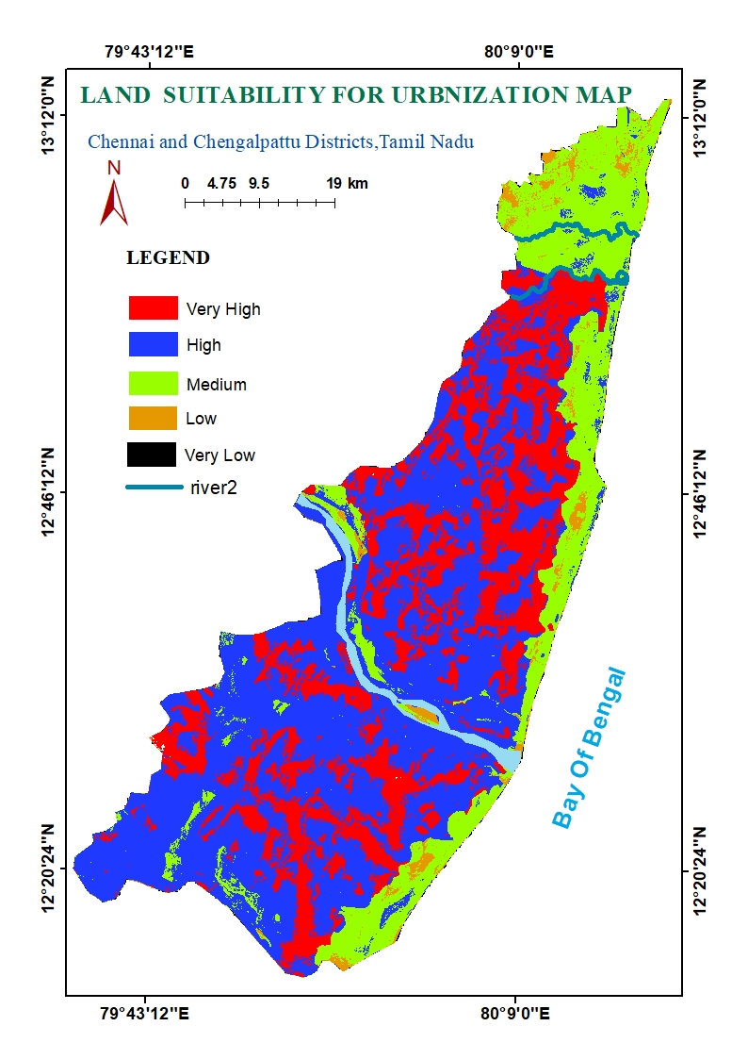

Figure 20 - AHP - Land suitability map

## CONCLUSIONS:

In this GIS based study, Multi Criteria evaluation technique – AHP process is used which is very simple and flexible, for finding land suitability categories in Chennai and Chengalpattu districts. It provides comprehensive and satisfactory data analysis or the availability of suitable land for developmental work is in turn will also help in solving any specific problem. This AHP model can also encourage public participation in the urban decision making process and assist various planners and authorities to formulate suitable plan for sustained development of the region. Based on the result the final map is classified into five categories very high, high, medium, low, very low. The theoretical methodology implemented in the present study will help to locate suitable sites for land development in other parts of the world. The result of the study will help the local people as well as planners to frame and implement suitable and sustainable plans for the development of the urban region. This land suitability for urbanization gives a better solutions ment for the humans and very much useful for the sustainable development. The combination of remote sensing and GIS provides in- sights into the multidimensional phenomenon of urbanization which would be useful for planning works and many other works.

## REFERENCES:

**Aburas, Maher Milad, Sabrina Ho Abdullah, Mohammad Firuz Ramli, and Zulfa Hanan. 2015. “A Review of Land Suitability Analysis for Urban Growth by Using the GIS-Based Analytic Hierarchy Process.” *Asian Journal of Applied Sciences* 03 (06): 869–76.**

**Aithal, Bharath H., and T. V. Ramachandra. 2016. “Visualization of Urban Growth Pattern in Chennai Using Geoinformatics and Spatial Metrics.” *Journal of the Indian Society of Remote Sensing* 44 (4): 617–33. https://doi.org/10.1007/s12524-015-0482-0.**

**Aliani, Hamide, Mohadeseh Ghanbari Motlagh, Ghazaleh Danesh, and Hamed Aliani. 2021. “Land Suitability Analysis for Urban Development Using TOPSIS, WLC and ANP Techniques (Eastern Cities of Gilan-Iran).” *Arabian Journal of Geosciences* 14 (13). https://doi.org/10.1007/s12517-021-07606-1.**

**Bagheri, Milad, Wan Nor Azmin Sulaiman, and Negin Vaghefi. 2013. “Application of Geographic Information System Technique and Analytical Hierarchy Process Model for Land-Use Suitability Analysis on Coastal Area.” *Journal of Coastal Conservation* 17 (1): 1–10. https://doi.org/10.1007/s11852-012-0213-4.**

**Chandio, Imtiaz Ahmed, Abdul Nasir Matori, Dano Umar Lawal, and Soheil Sabri. 2011. “GIS-Based Land Suitability Analysis Using AHP for Public Parks Planning in Larkana City.” *Modern Applied Science* 5 (4): 177–89. https://doi.org/10.5539/mas.v5n4p177.**

**Jafari, Sudabe, and Narges Zaredar. 2010. “Land Suitability Analysis Using Multi Attribute.” *International Journal of Environmental Science and Development* 1 (5): 441–45.**

**Jamil, Mubashir, Raihan Ahmed, and Haroon Sajjad. 2018. “Land Suitability Assessment for Sugarcane Cultivation in Bijnor District, India Using Geographic Information System and Fuzzy Analytical Hierarchy Process.” *GeoJournal* 83 (3): 595–611. https://doi.org/10.1007/s10708-017-9788-5.**

**KUMAR, Manish, and Vivekananda BISWAS. 2013. “Identification of Potential Sites for Urban Development Using GIS Based Multi Criteria Evaluation Technique . A Case Study of Shimla Municipal Area , Shimla District ,.” *Journal of Settlements and Spatial Planning* 4 (August): 45–51.**

**Kumar, Manish, and Vasim Riyasat Shaikh. 2013. “Site Suitability Analysis for Urban Development Using GIS Based Multicriteria Evaluation Technique: A Case Study of Mussoorie Municipal Area, Dehradun District, Uttarakhand, India.” *Journal of the Indian Society of Remote Sensing* 41 (2): 417–24. https://doi.org/10.1007/s12524-012-0221-8.**

**Murgante, Beniamino, and Giuseppe Las Casas. 2004. “G.I.S. and Fuzzy Sets for the Land Suitability Analysis.” *Lecture Notes in Computer Science (Including Subseries Lecture Notes in Artificial Intelligence and Lecture Notes in Bioinformatics)* 3044: 1036–45. https://doi.org/10.1007/978-3-540-24709-8_109.**

**Park, Soyoung, Seongwoo Jeon, Shinyup Kim, and Chuluong Choi. 2011. “Prediction and Comparison of Urban Growth by Land Suitability Index Mapping Using GIS and RS in South Korea.” *Landscape and Urban Planning* 99 (2): 104–14. https://doi.org/10.1016/j.landurbplan.2010.09.001.**

**Parry, Jahangeer A., Showkat A. Ganaie, and M. Sultan Bhat. 2018. “GIS Based Land Suitability Analysis Using AHP Model for Urban Services Planning in Srinagar and Jammu Urban Centers of J&K, India.” *Journal of Urban Management* 7 (2): 46–56. https://doi.org/10.1016/j.jum.2018.05.002.**

**Yeh, Anthony Gar On, and Xia Li. 1998. “Sustainable Land Development Model for Rapid Growth Areas Using GIS.” *International Journal of Geographical Information Science* 12 (2): 169–89. https://doi.org/10.1080/136588198241941.**